Home Page

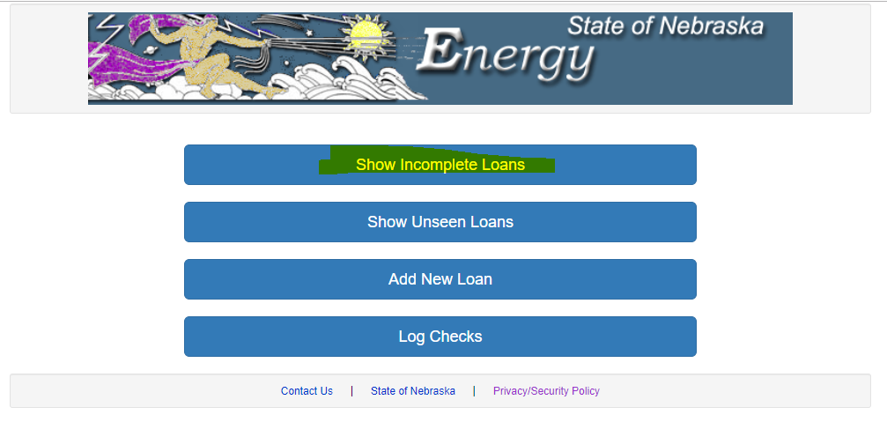

On pressing 🡺 Add New Loan

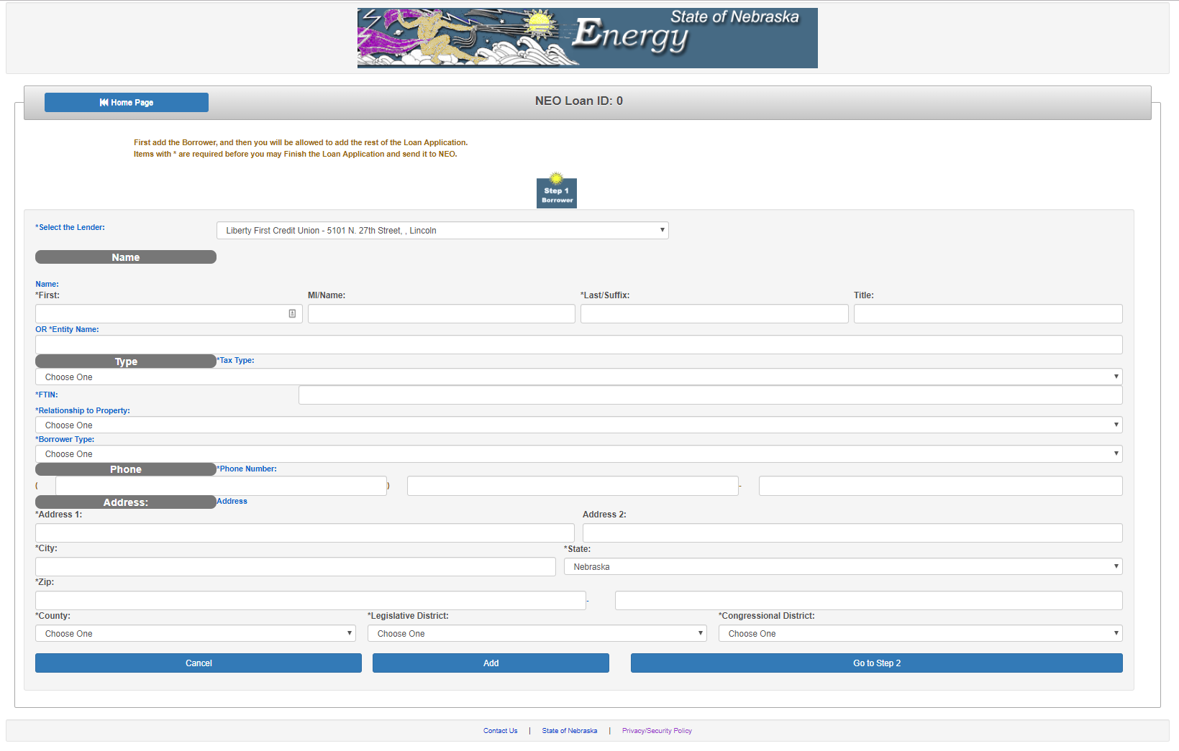

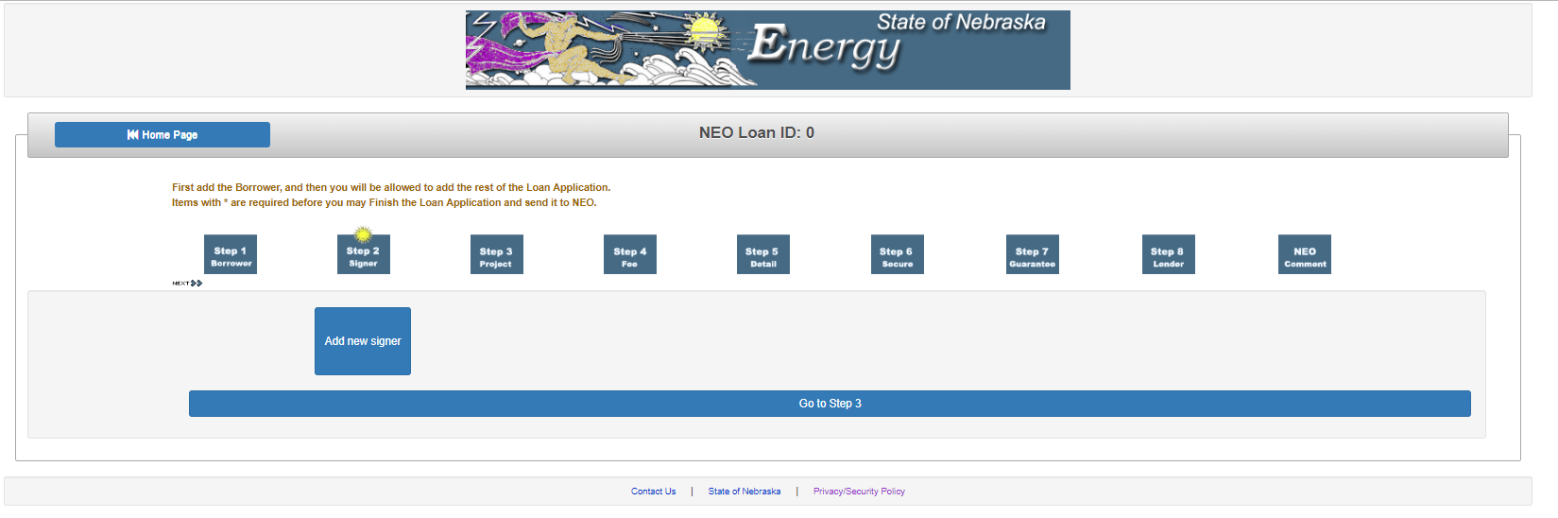

On pressing 🡺 Add New Signer

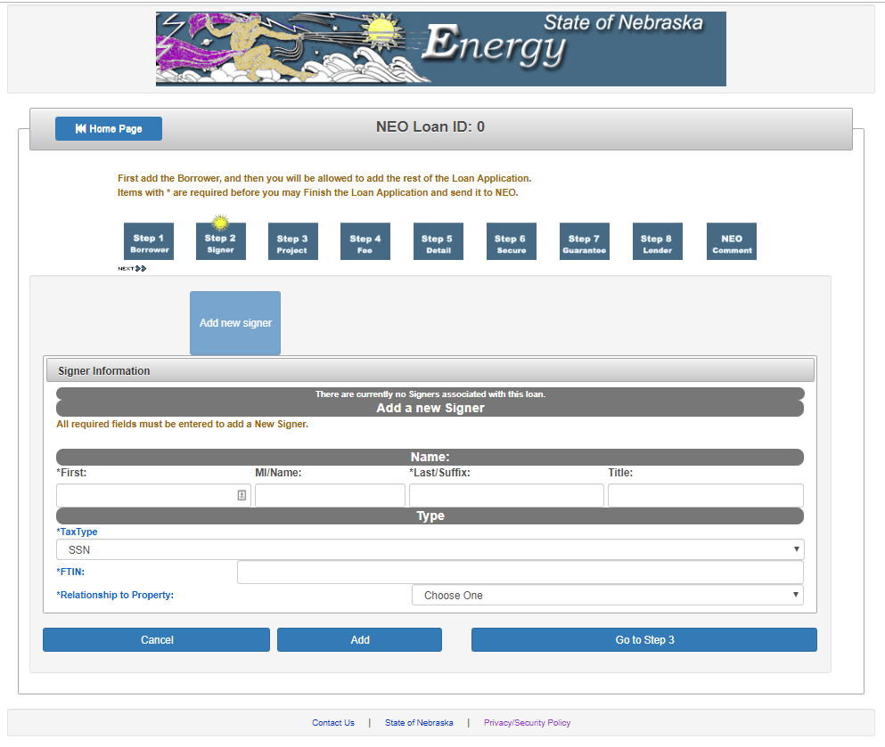

Tax Type: dropdown

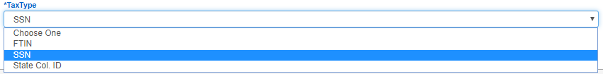

FTIN: dropdown

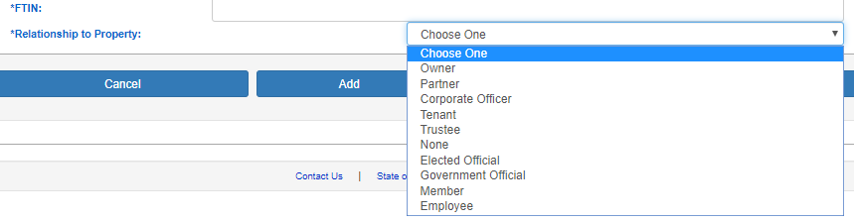

On pressing 🡺 go to Step 3

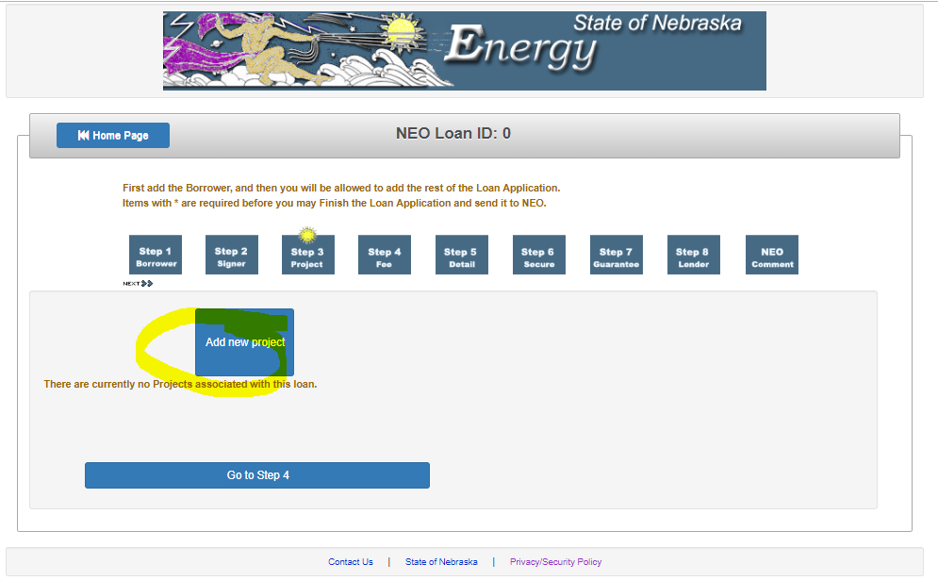

On pressing Add new Project

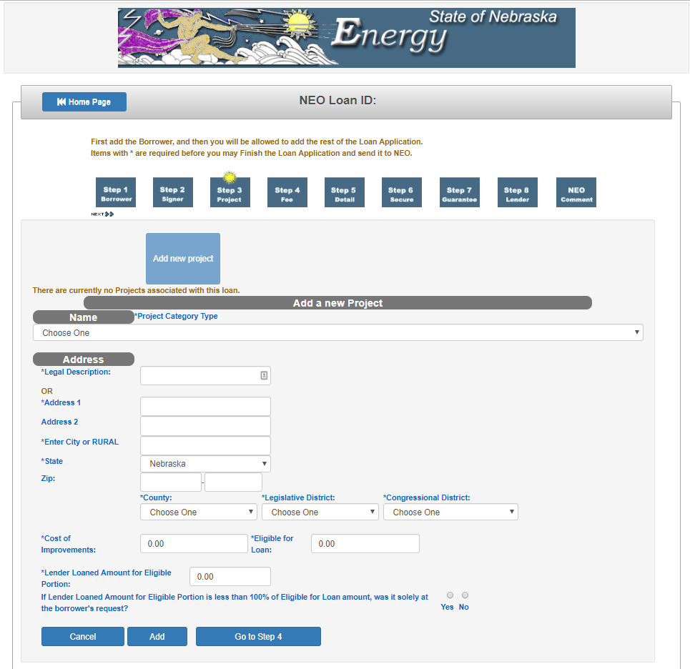

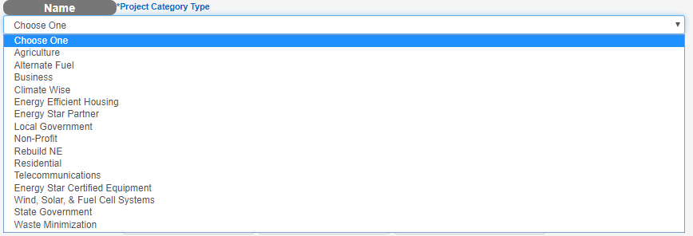

There are more dropdowns like that



On pressing 🡺 go to Step 4 🡺 will let you know more later once you are done until here.